1) Setup a virtual machine using Ubuntu image.  
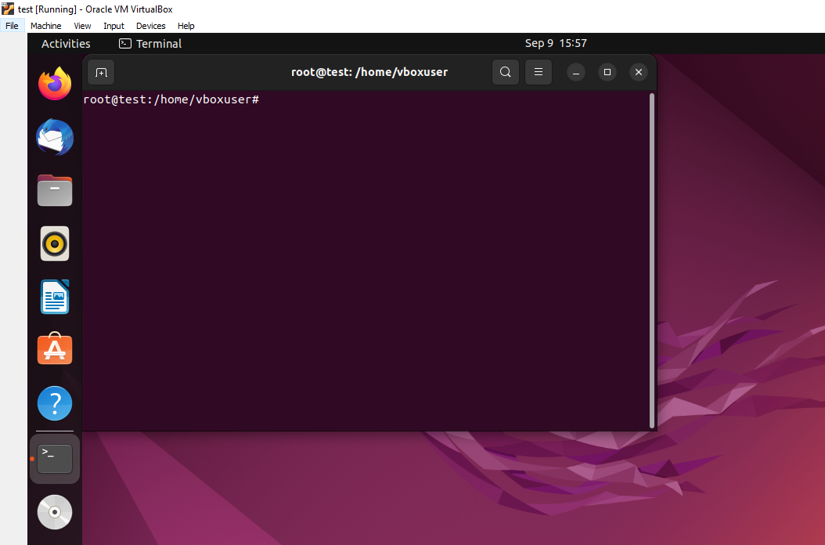

2) Install docker on ec2.  
yum –y install docker   
systemctl start docker   
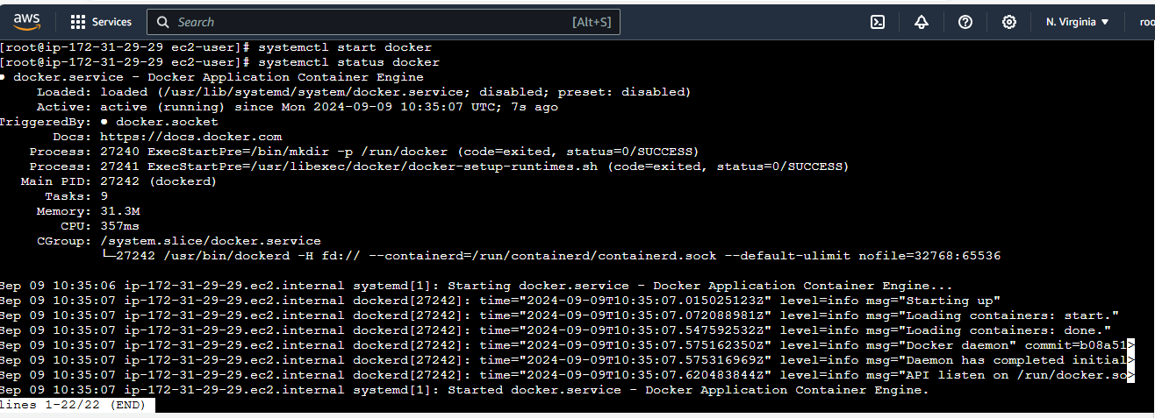

3) Pull 5 docker images.(nginx,apache tomcat,ubuntu,jenkins,sonarqube)  
1st Nginx:  
  
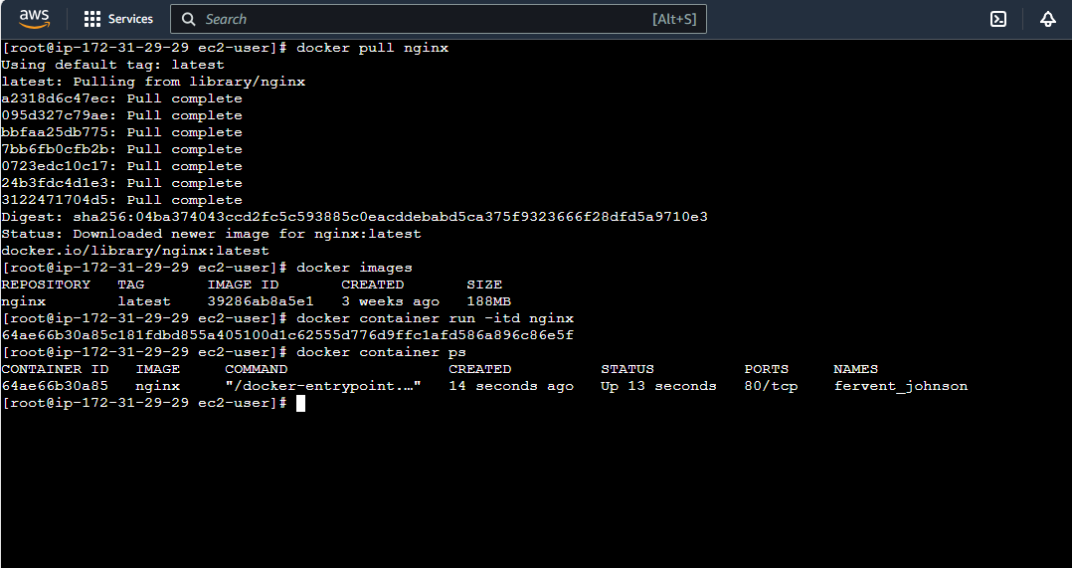  
  
2nd Apache :  
  
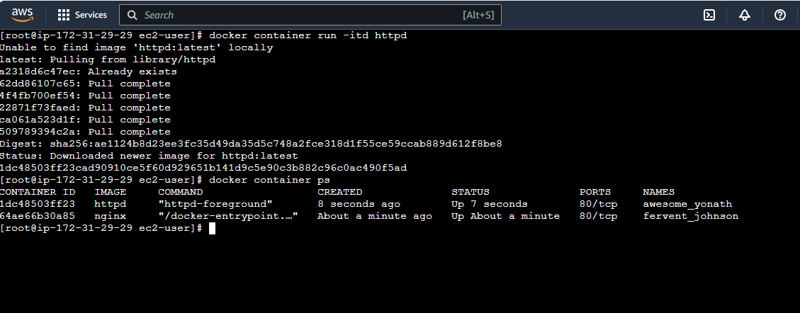

3rd tomcat:  
  
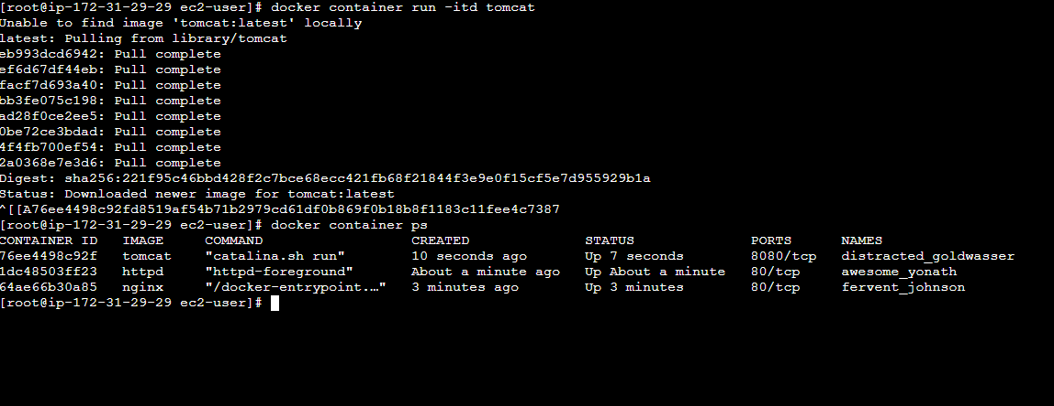  
  
4th ubuntu:  
  
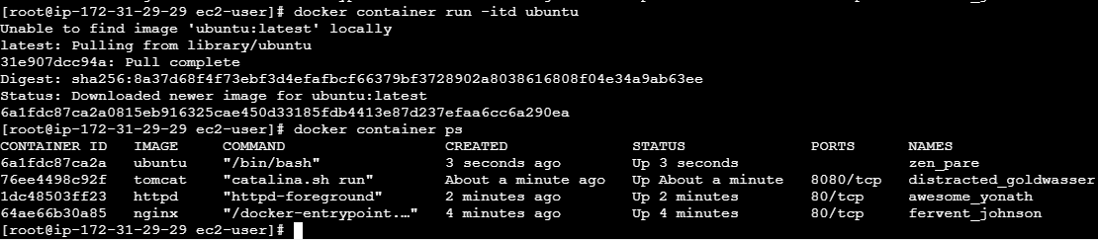

5th Jenkins:  
Got an error:  
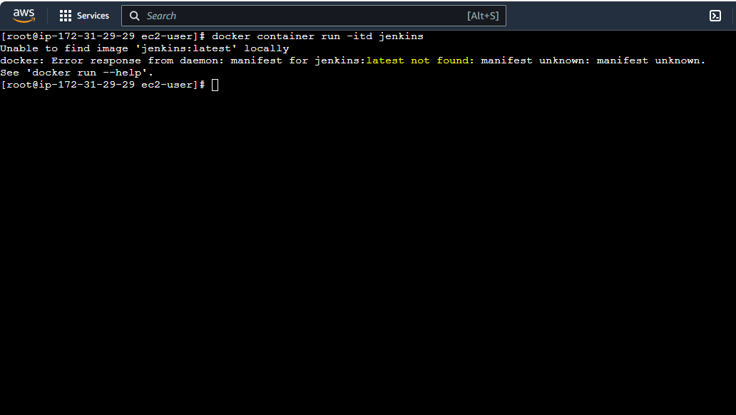  
The Tag was not available in docker hub found the error and solved it:  
 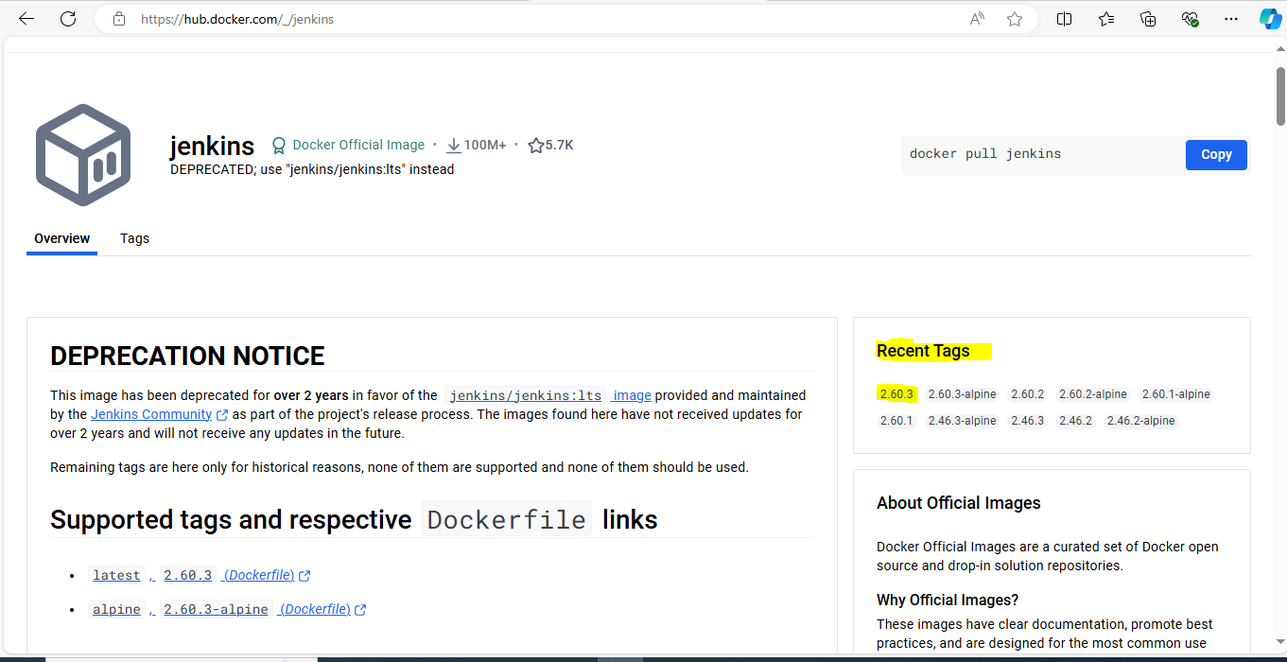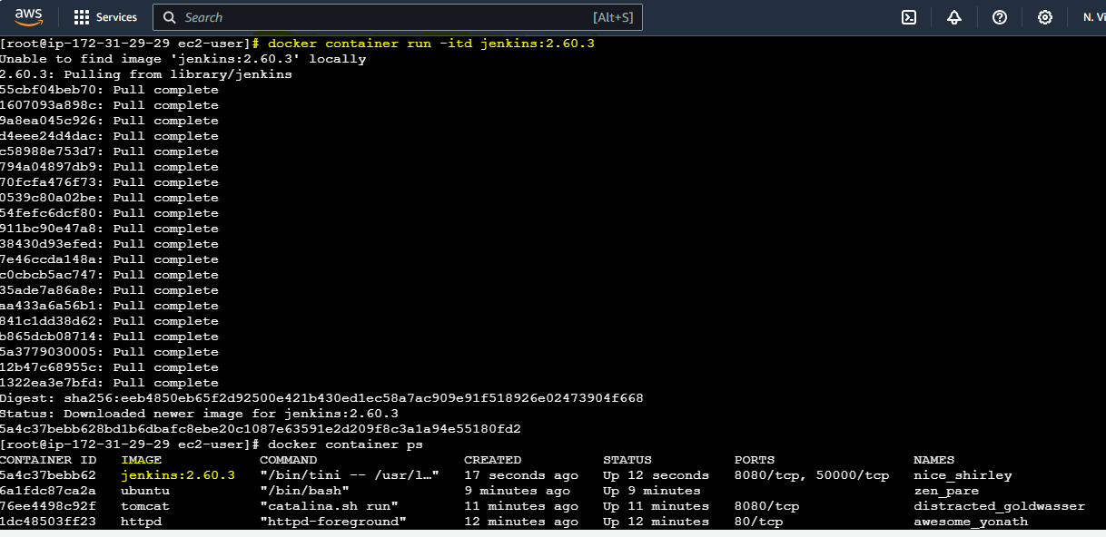

5th Sonarqube:  
  
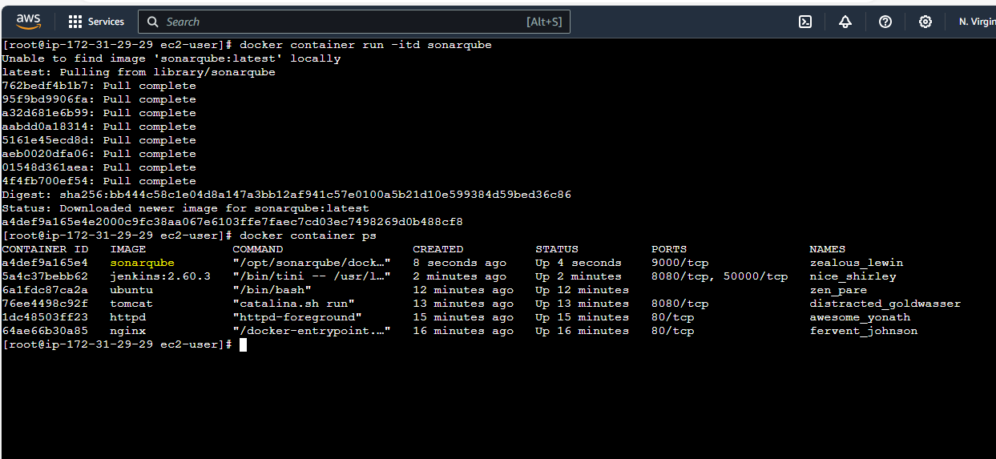  
  
  
4) Run nginx container and expose on port 81.  
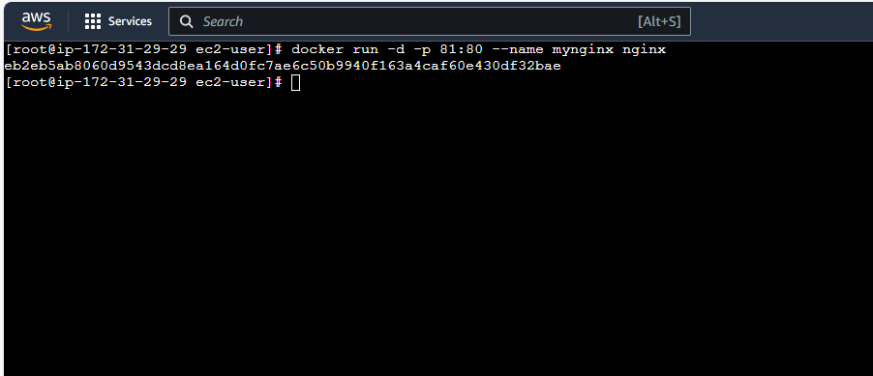  
  
webUI:  
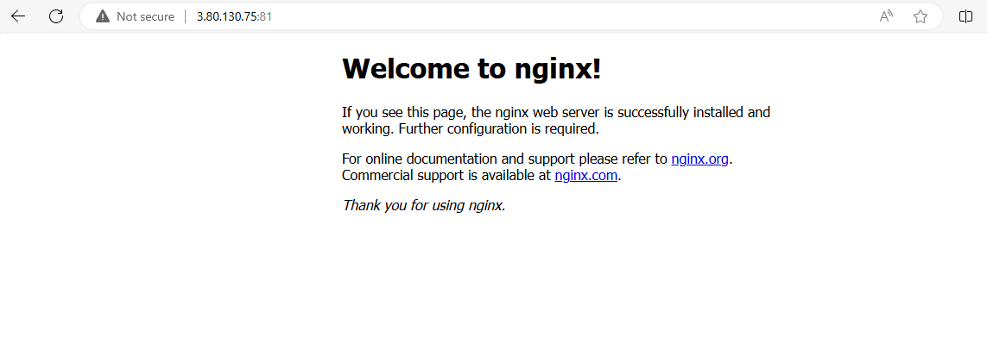

5) Delete the apache tomcat image from local:   
Got errors:  
  
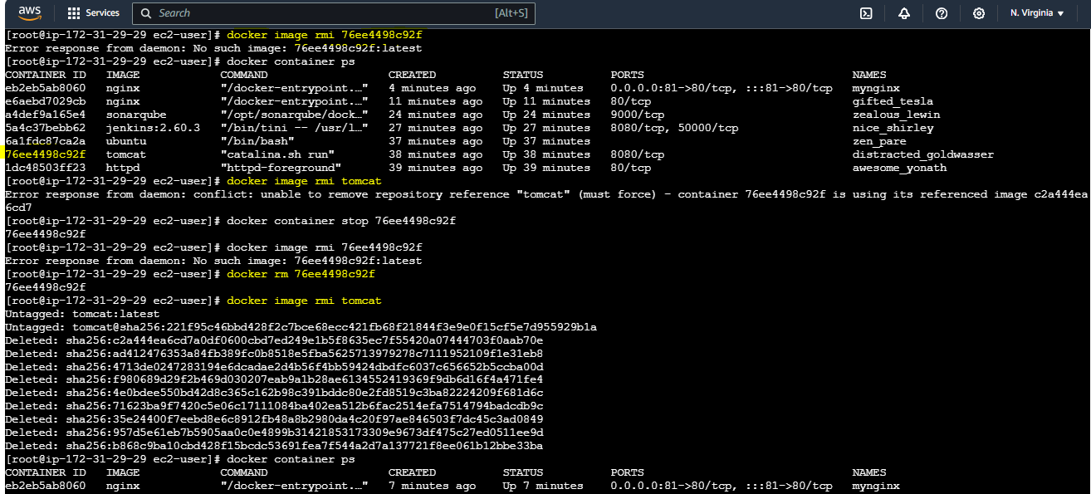  
Stop the container using the Tomcat image  
docker stop 76ee4498c92f  
Remove the stopped container:  
docker rm 76ee4498c92f  
Remove the Tomcat image:  
docker image rmi tomcat  
 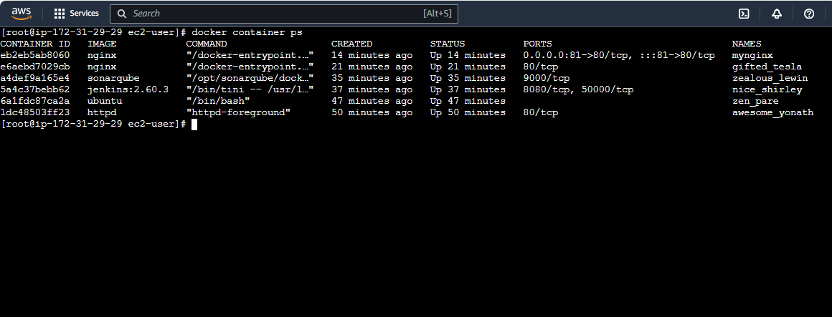

6) Inspect the jenkins image,sonarqube image.  
Jenkins:  
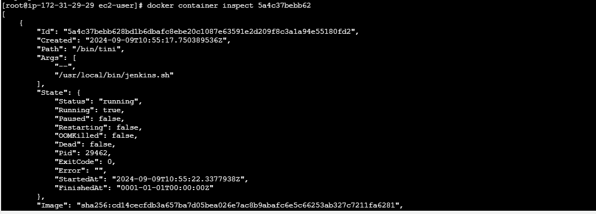  
  
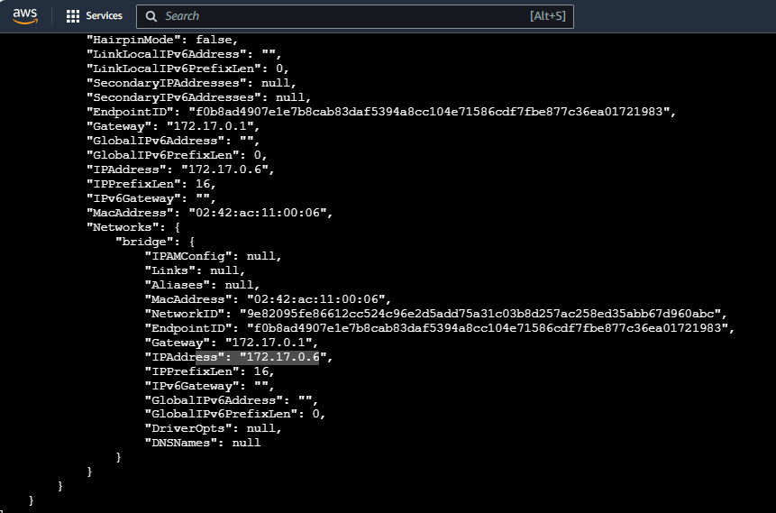  
  
  
  
  
  
  
for Sonarqube:  
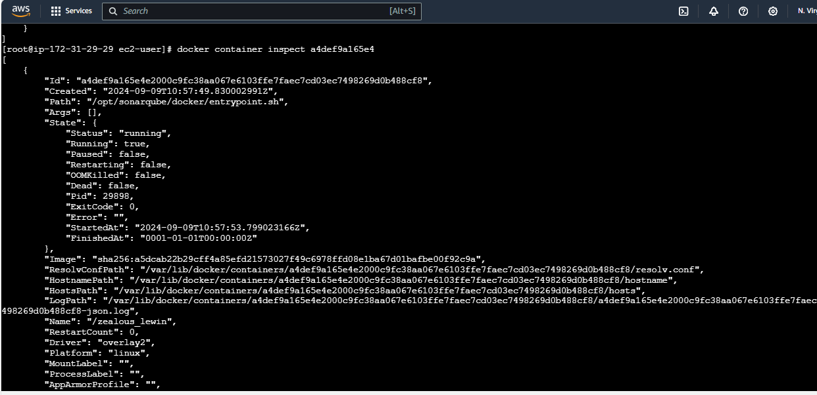  
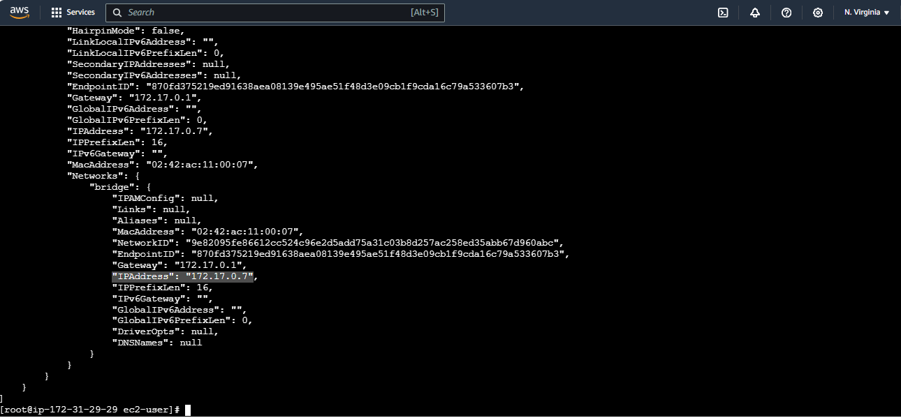

7) Run jenkins container and run one sample job.  
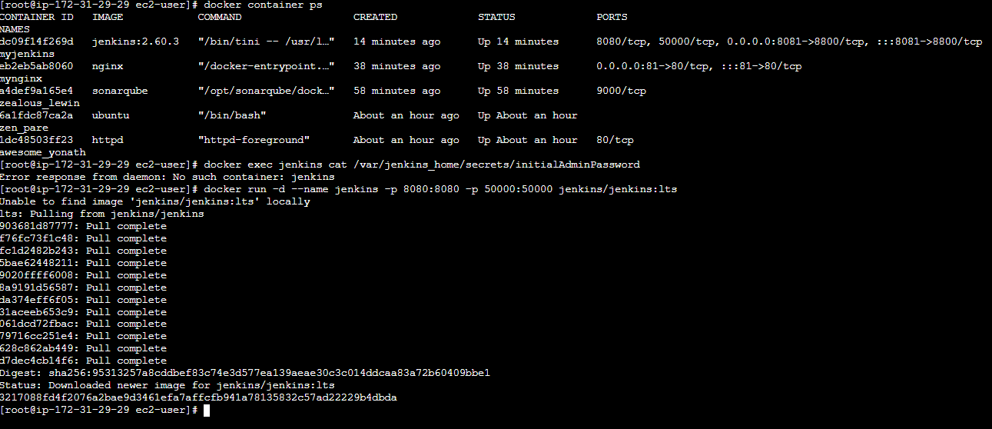  
  
To know the initial password:  
  
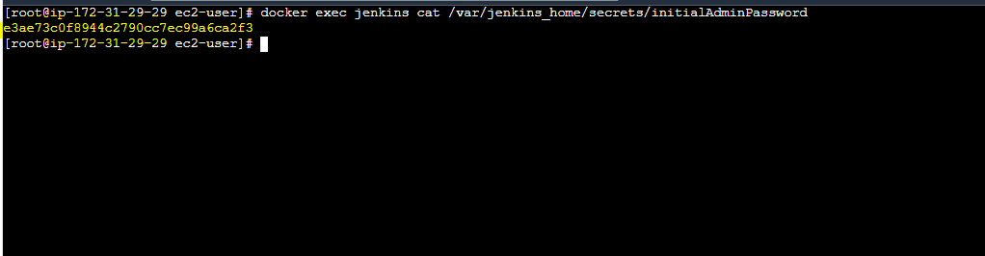  
Started the Jenkins :  
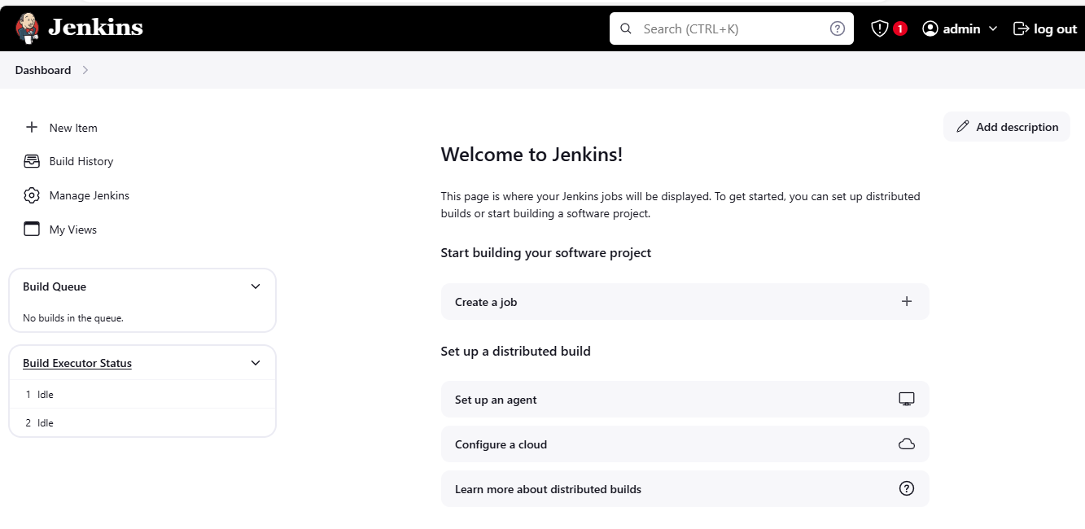  
now running a sample job on it:  
  
